SEIP PCM DMA Interface

Version 1.0

SHMT Co., Ltd.

REVISION HISTORY
Version | Detail(굴림/Verdana 10pt bold) | Name | Date
1.0 | SEIP PCM DMA Interface Controller Spec. Created | East | 2007-1-14

Technical documents
Copyright © 2007 Shmt Limited. All rights reserved.

Confidentiality Status
This document is NOT OPEN ACCESS. The distribution is restricted to certified company.
This document is CONFIDENTIAL.

Feedback on this document
If you have any comments on this document, please contact your channel to our company.

Shmt Web address
http://www.shmt.com

Contents

1. Function Description 7
1.1. Overview 7
1.1.1. Feature 7
1.1.2. Block Diagram 8
1.2. Operation 8
1.2.1. Interface Controller Block 9
1.3. Register Description 10
1.3.1. PCM Registers 10
1.3.2. PCM RX DMA Control Register 11
1.3.3. PCM RX DMA Status Register 11
1.3.4. PCM RX DMA Data Register 12
1.3.5. PCM TX DMA Control Register 13
1.3.6. PCM TX DMA Status Register 13
1.3.7. PCM TX DMA Data Register 14
1.3.8. SEIP RESET Register 15

Figures

Figure 1 SEIP Interface Top Block Diagram 8

Tables
Table 1-1 PCM Registers(Base Address : 1FFF 0000h) 10
Table 1-2 PCM RX DMA Control Register Description(Offset : 0000 2000h) 11
Table 1-3 PCM RX DMA Status Register Description(Offset : 0000 2004h) 12
Table 1-4 PCM RX DMA Data Register Description(Offset : 0000 2008h) 12

Function Description

Overview

Feature

- Support Voice Recoding and Playing by PCM of SEIP(Sound Engine) Interface.
- Support DMA/CPU Access Interface by AMBA3 APB.

Block Diagram

Figure 1 SEIP Interface Top Block Diagram

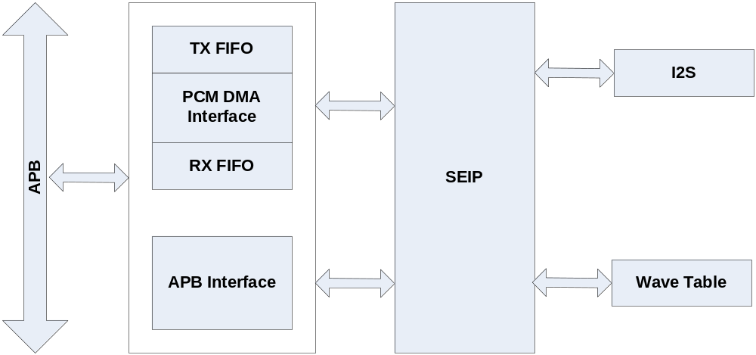

Operation

TX/RX FIFO의 크기는 32bit width의 8개의 depth를 갖는다.
TX/RX DMA는 System DMA와 연동하여 동작한다.
즉, FIFO의 상황에 의해 생성되는 DMA Request에 의해 System DMA가 PCM data를 FIFO에 채우거나(RX), 꺼내는(TX) 동작을 한다.

Register Description

PCM Registers

Table 1-1 PCM Registers(Base Address : 1FFF 0000h)
Offset | Name | R/W | Description | Init. value
2000h | RXCON | RW | PCM RX Control Register | 0000 0000h
2004h | RXSTS | RW | PCM RX Status Register | 0000 0000h
2008h | RXDAT | RW | PCM RX DATA Register | 0000 0000h
2010h | TXCON | RW | PCM TX Control Register | 0000 0000h
2014h | TXSTS | RW | PCM TX Status Register | 0000 0000h
2018h | TXDAT | RW | PCM TX DATA Register | 0000 0000h
2020h | SEIPRST | RW | SEIP RESET Register | 0000 0000h

PCM RX DMA Control Register

Figure 2-1 PCM RX DMA Control Register Bits
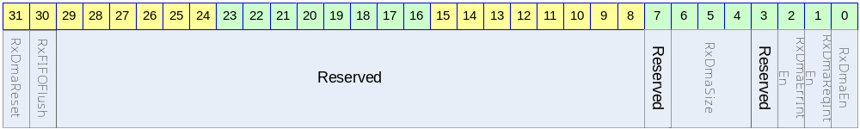

Table 1-2 PCM RX DMA Control Register Description(Offset : 0000 2000h)
Bits | Name | R/W | Description | Init. value
[31] | RxDmaReset | W | Reset PCM RX DMA  1 : Reset  0 : Set | 0
[30] | RxFIFOFlush | W | Reset PCM RX DMA FIFO  1 : Reset  0 : Set | 0
[29:7]
[6:4] | RxDmaSize | RW | PCM RX DMA FIFO Fill Level  Fill Level 이상의 FIFO의 공간이 있으면 DMA Request를 생성하게 된다. | 3
[3] |  |  | Reserved | 0
[2] | RxDmaErrIntEn | RW | 전송 에러가 나면 인터럽트를 걸지 여부를 결정한다.  0 : Disable  1 : Enable | 0
[1] | RxDmaReqIntEn | RW | 설정된 DMA FIFO Level 만큼 FIFO의 공간이 있으면 인터럽트를 걸지 여부를 결정한다.  0 : Disable  1 : Enable | 0
[0] | RxDmaEn | RW | PCM RX DMA Enable  0 : Disable  1 : Enable | 0

PCM RX DMA Status Register

Figure 2-2 PCM RX DMA Status Register Bits
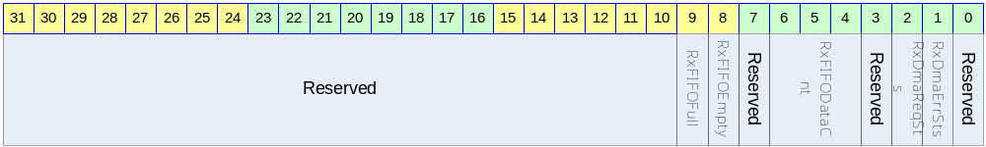

Table 1-3 PCM RX DMA Status Register Description(Offset : 0000 2004h)
Bits | Name | R/W | Description | Init. value
[31:10] |  |  | Reserved | 0
[9] | RxFIFOFull | R | PCM RX FIFO Full Status | 0
[8] | RxFIFOEmpty | R | PCM RX FIFO Empty Status | 0
[7] |  |  | Reserved
[6:4] | RxFIFODataCnt | R | PCM RX FIFO Data Count | 0
[3] |  |  | Reserved
[2] | RxDmaReqSts | R | PCM RX DMA Request Interrupt Status  When Write 1, Cleared to zero | 0
[1] | RxDmaErrSts | R | PCM RX DMA Error Interrupt Status  When Write 1, Cleared to zero | 0

PCM RX DMA Data Register

Figure 2-3 PCM RX DMA Data Register Bits
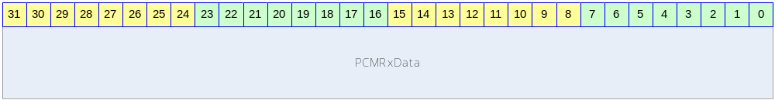

Table 1-4 PCM RX DMA Data Register Description(Offset : 0000 2008h)
Bits | Name | R/W | Description | Init. value
[31:0] | PCMRXData | RW | Write : DMA/CPU Interface  Read : CPU Interface | 0

PCM TX DMA Control Register

Figure 2-4 PCM TX DMA Control Register Bits
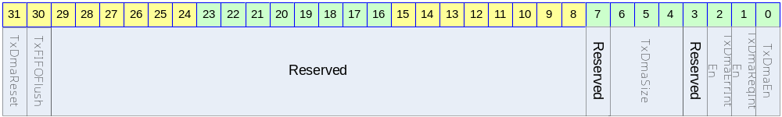

Table 1-5 PCM TX DMA Control Register Description(Offset : 0000 2010h)
Bits | Name | R/W | Description | Init. value
[31] | TxDmaReset | W | Reset PCM TX DMA  1 : Reset  0 : Set | 0
[30] | TxFIFOFlush | W | Reset PCM TX DMA FIFO  1 : Reset  0 : Set
[29:7]
[6:4] | TxDmaSize | RW | PCM TX DMA FIFO Level  한번에 전송할 수 있는 DMA Size로 설정한다. | 0
[3] |  |  | Reserved | 0
[2] | TxDmaErrIntEn | RW | 전송 에러가 나면 인터럽트를 걸지 여부를 결정한다.  0 : Disable  1 : Enable | 0
[1] | TxDmaReqIntEn | RW | 설정된 DMA SIZE 만큼 FIFO가 차면 인터럽트를 걸지 여부를 결정한다.  0 : Disable  1 : Enable | 0
[0] | TxDmaEn | RW | PCM TX DMA Enable  0 : Disable  1 : Enable | 0

PCM TX DMA Status Register

Figure 2-6 PCM TX DMA Status Register Bits
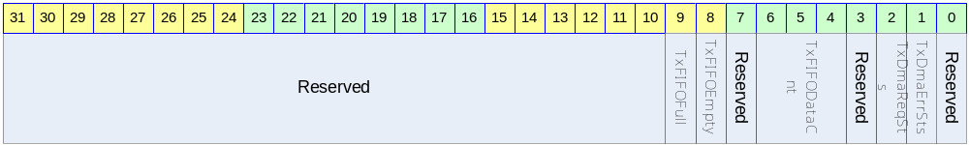

Table 1-7 PCM TX DMA Status Register Description(Offset : 0000 2014h)
Bits | Name | R/W | Description | Init. value
[31:10] |  |  | Reserved | 0
[9] | TxFIFOFull | R | PCM TX FIFO Full Status
[8] | TxFIFOEmpty | R | PCM TX FIFO Empty Status
[7] |  |  | Reserved
[6:4] | TxFIFODataCnt | R | PCM TX FIFO Data Count
[3] |  |  | Reserved
[2] | TxDmaReqSts | R | PCM TX DMA Request Interrupt Status  When Write 1, Cleared to zero | 0
[1] | TxDmaErrSts | R | PCM TX DMA Error Interrupt Status  When Write 1, Cleared to zero | 0

PCM TX DMA Data Register

Figure 2-8 PCM TX DMA Data Register Bits
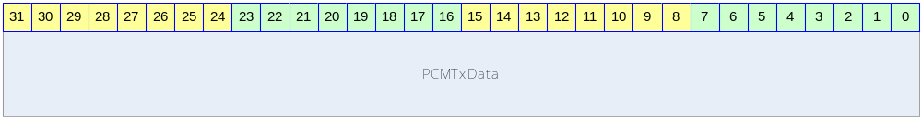

Table 1-9 PCM TX DMA Data Register Description(Offset : 0000 2018h)
Bits | Name | R/W | Description | Init. value
[31:0] | PCMTXData | RW | Write : CPU Interface  Read : DMA/CPU Interface | 0

SEIP RESET Register

Figure 2-10 SEIP RESET DRegister Bits
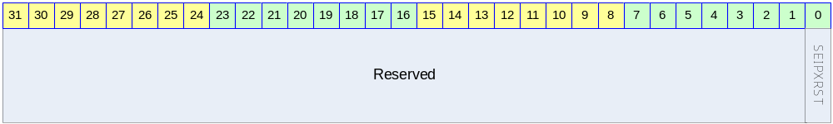

Table 1-11 SEIP RESET Register Description(Offset : 0000 2020h)
Bits | Name | R/W | Description | Init. value
[31:1] |  |  | Reserved | 0
[0] | SEIPXRST | RW | 0 : SEIP Reset Active  1 : SEIP Reset Inactive | 1

